Landscape Monitoring Framework Estimates By State By Type: BLM Rangelands West-Wide
4/16/2020

Figure 1: Proportion of BLM rangelands with none-to-slight or slight-to-moderate departure from biotic integrity reference conditions (BI <=2) (80% confidence interval)
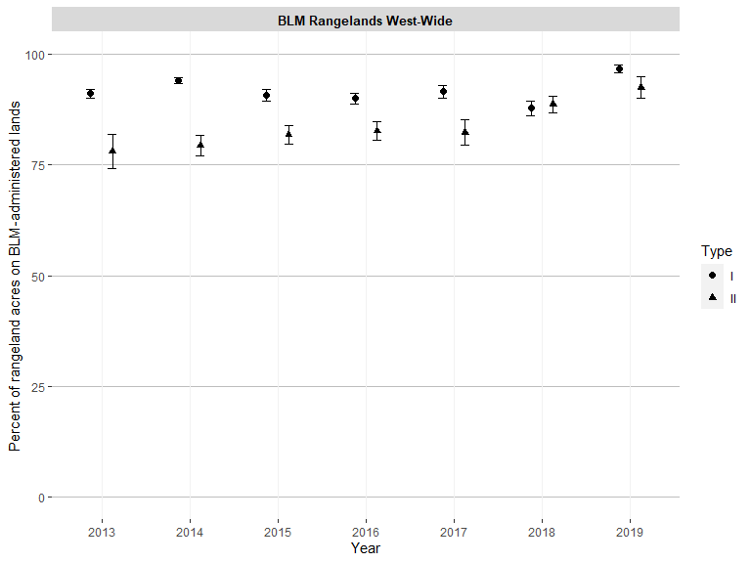

Figure 2: BLM rangeland acres with none-to-slight or slight-to-moderate departure from biotic integrity reference conditions (BI <=2) (80% confidence interval)
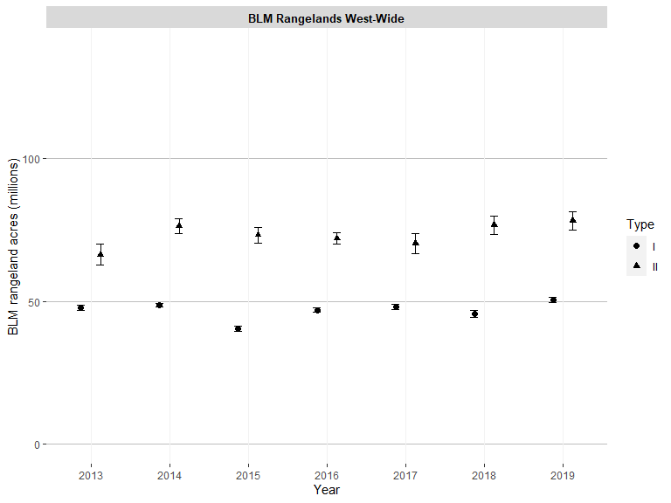

Figure 3: Proportion of BLM rangelands with moderate departure from biotic integrity reference conditions (BI = 3) (80% confidence interval)
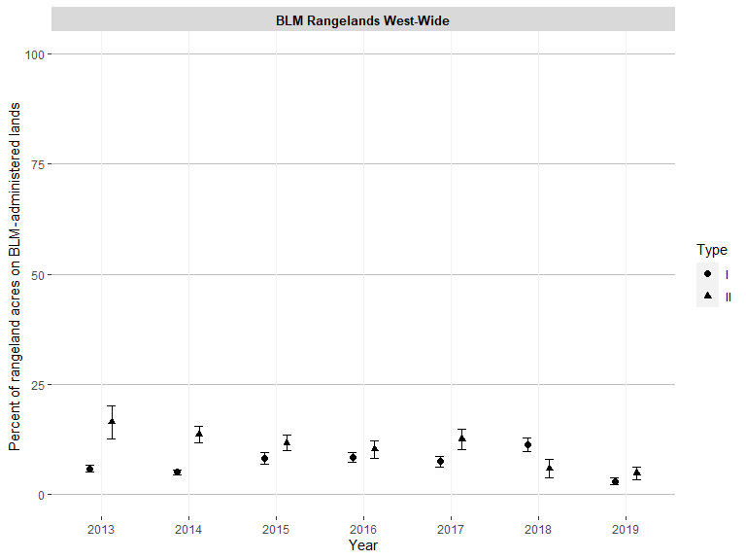

Figure 4: BLM rangeland acres with moderate departure from biotic integrity reference conditions (BI = 3) (80% confidence interval)
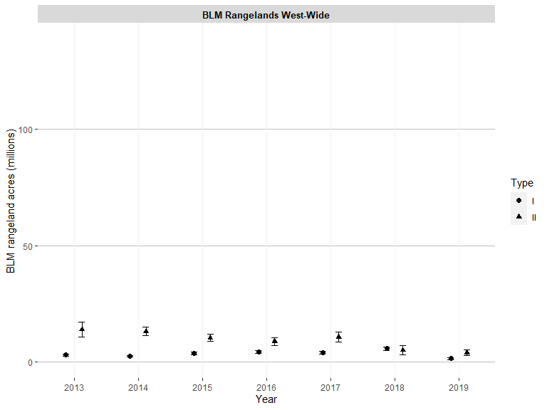

Figure 5: Proportion of BLM rangelands with moderate or moderate-to-extreme or extreme-to-total departure from biotic integrity reference conditions (BI >=3) (80% confidence interval)
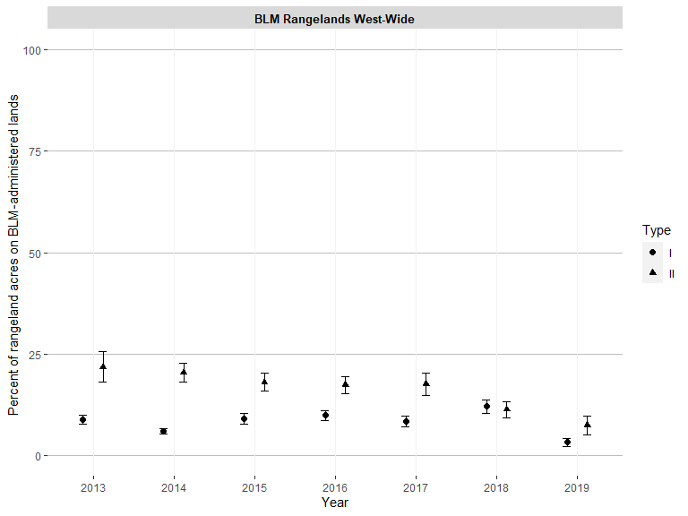

Figure 6: BLM rangeland acres with moderate or moderate-to-extreme or extreme-to-total departure from biotic integrity reference conditions (BI >=3) (80% confidence interval)
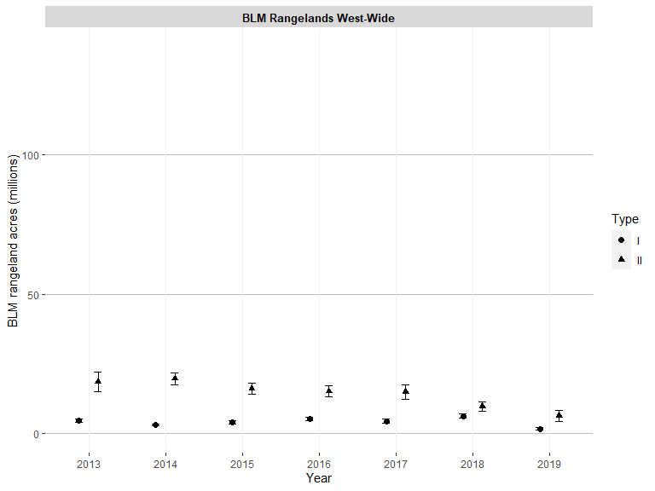

Figure 7: Proportion of BLM rangelands with moderate-to-extreme or extreme-to-total departure from biotic integrity reference conditions (BI >= 4) (80% confidence interval)
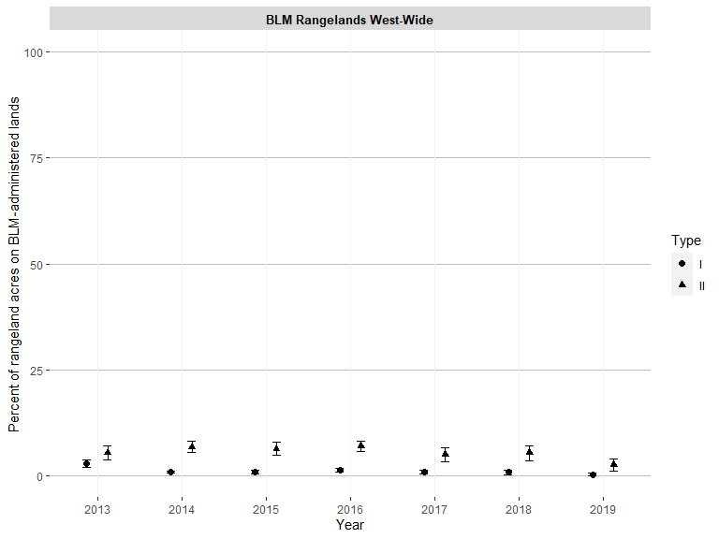

Figure 8: BLM rangeland acres with moderate-to-extreme or extreme-to-total departure from biotic integrity reference conditions (BI >= 4) (80% confidence interval)
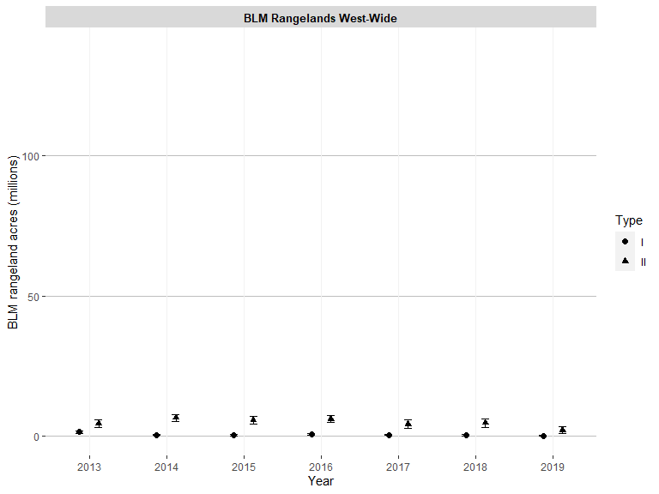

Figure 9: Proportion of BLM rangelands with none-to-slight or slight-to-moderate departure from hydrologic function reference conditions (HF <=2) (80% confidence interval)
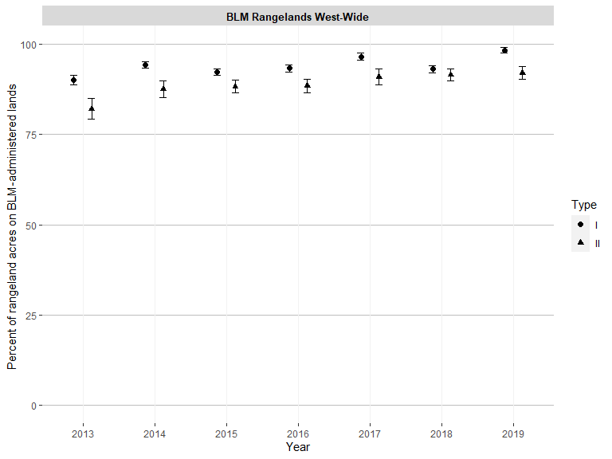

Figure 10: BLM rangeland acres with none-to-slight or slight-to-moderate departure from hydrologic function reference conditions (HF <=2) (80% confidence interval)
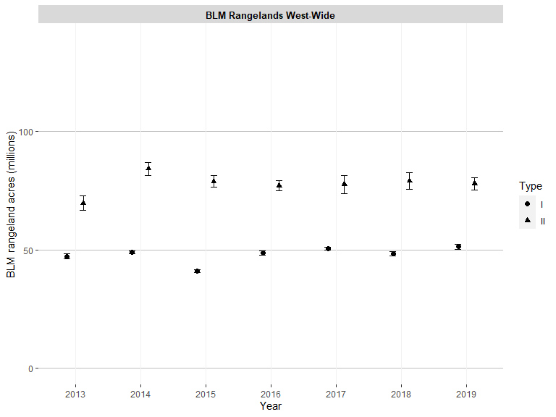

Figure 11: Proportion of BLM rangelands with moderate departure from hydrologic function reference conditions (HF = 3) (80% confidence interval)
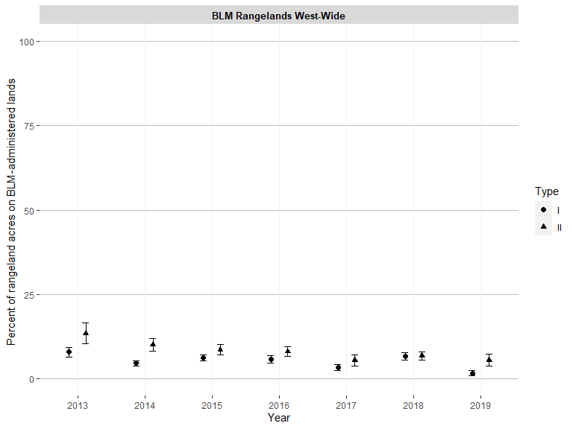

Figure 12: BLM rangeland acres with moderate departure from hydrologic function reference conditions (HF = 3) (80% confidence interval)
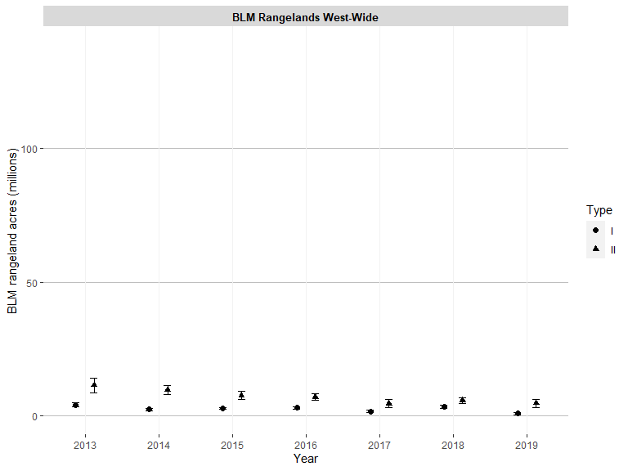

Figure 13: Proportion of BLM rangelands with moderate or moderate-to-extreme or extreme-to-total departure from hydrologic function reference conditions (HF >= 3) (80% confidence interval)
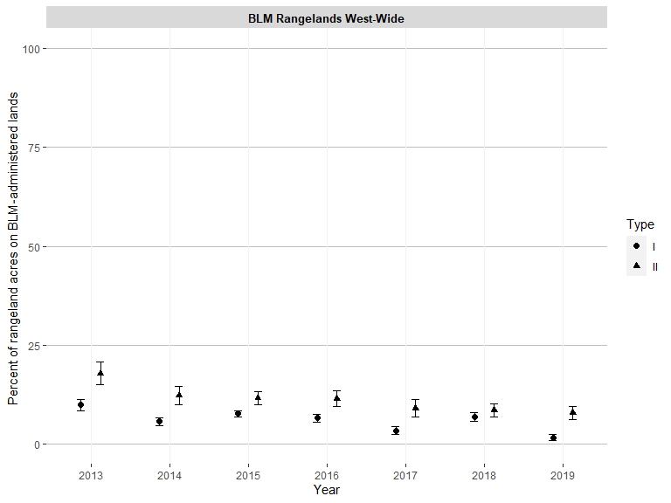

Figure 14: BLM rangeland acres with moderate or moderate-to-extreme or extreme-to-total departure from hydrologic function reference conditions (HF >= 3) (80% confidence interval)
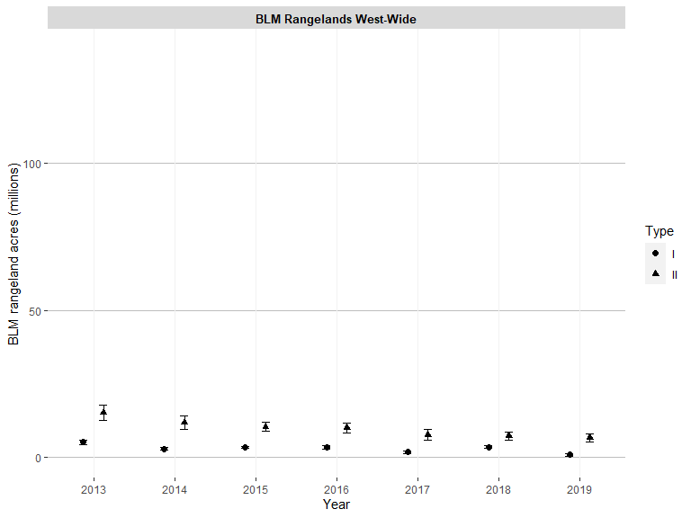

Figure 15: Proportion of BLM rangelands with moderate-to-extreme or extreme-to-total departure from hydrologic function reference conditions (HF >= 4) (80% confidence interval)
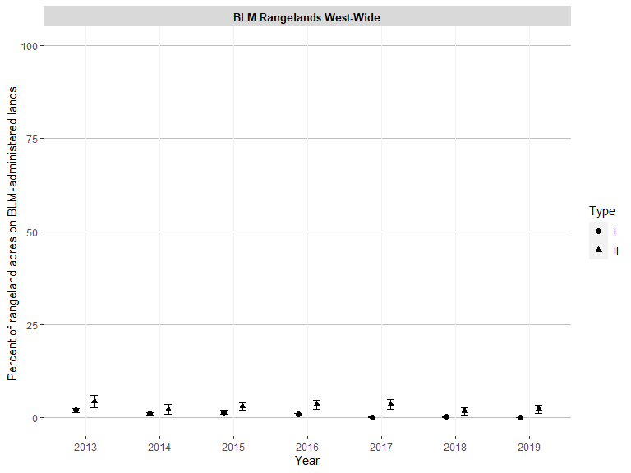

Figure 16: BLM rangeland acres with moderate-to-extreme or extreme-to-total departure from hydrologic function reference conditions (HF >= 4) (80% confidence interval)
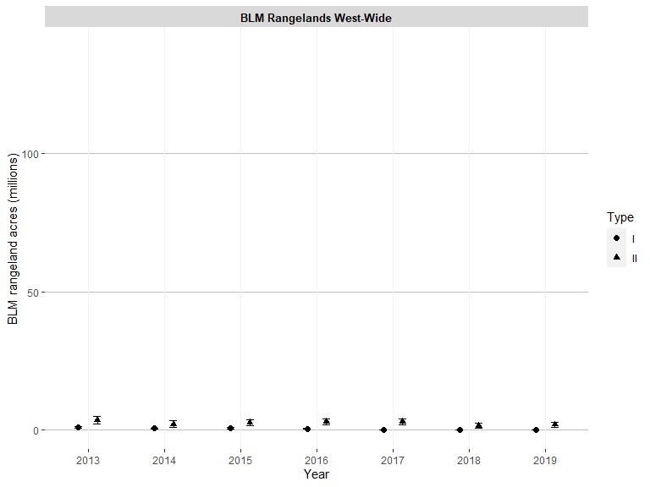

Figure 17: Proportion of BLM rangelands with none-to-slight or slight-to-moderate departure from soil and site stability reference conditions (SSS <=2) (80% confidence interval)
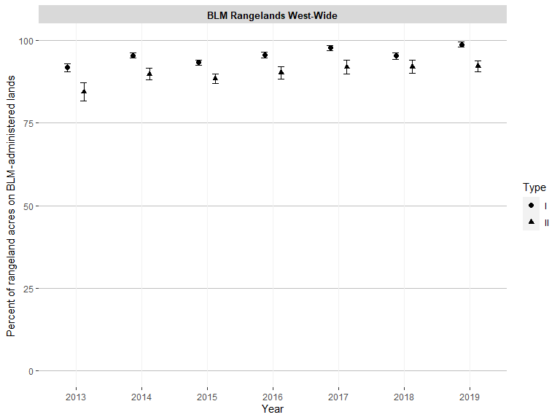

Figure 18: BLM rangeland acres with none-to-slight or slight-to-moderate departure from soil and site stability reference conditions (SSS <=2) (80% confidence interval)
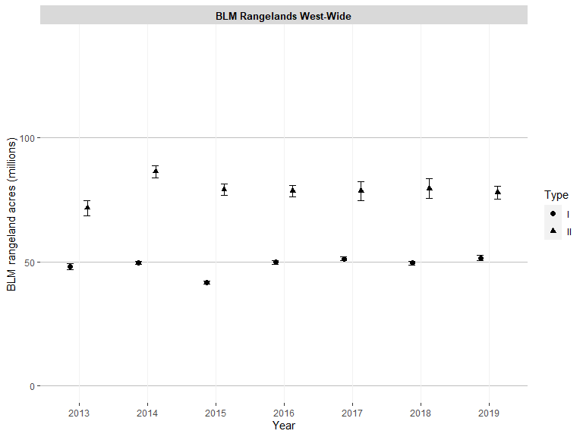

Figure 19: Proportion of BLM rangelands with moderate departure from soil and site stability reference conditions (SSS = 3) (80% confidence interval)
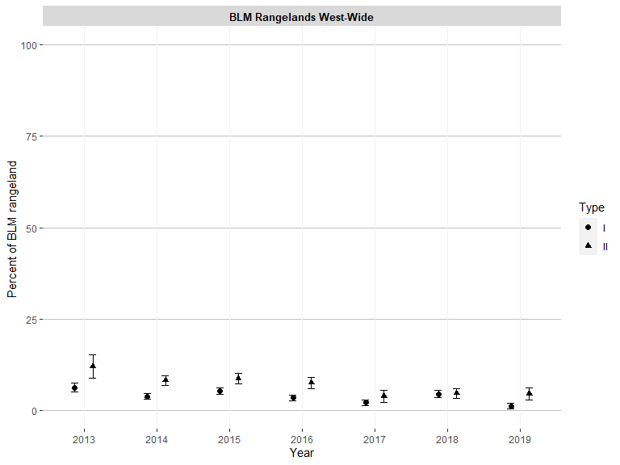

Figure 20: BLM rangeland acres with moderate departure from soil and site stability reference conditions (SSS = 3) (80% confidence interval)
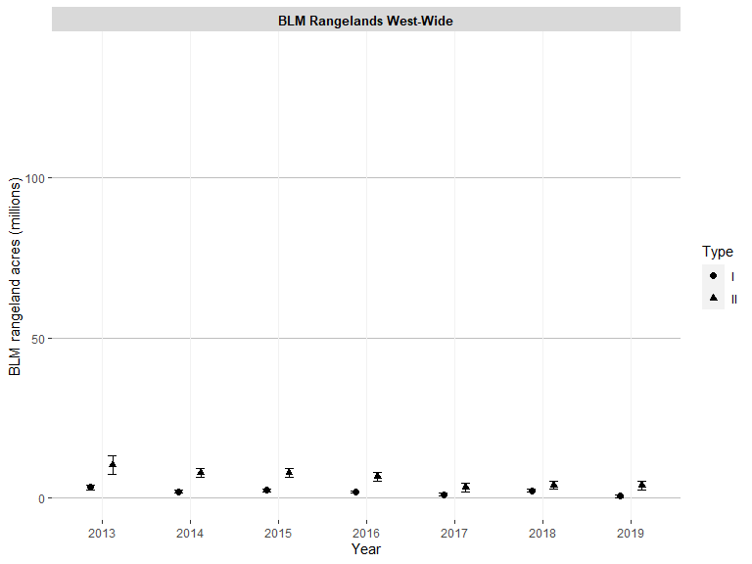

Figure 21: Proportion of BLM rangelands with moderate or moderate-to-extreme or extreme-to-total departure from soil and site stability reference conditions (SSS >= 3) (80% confidence interval)
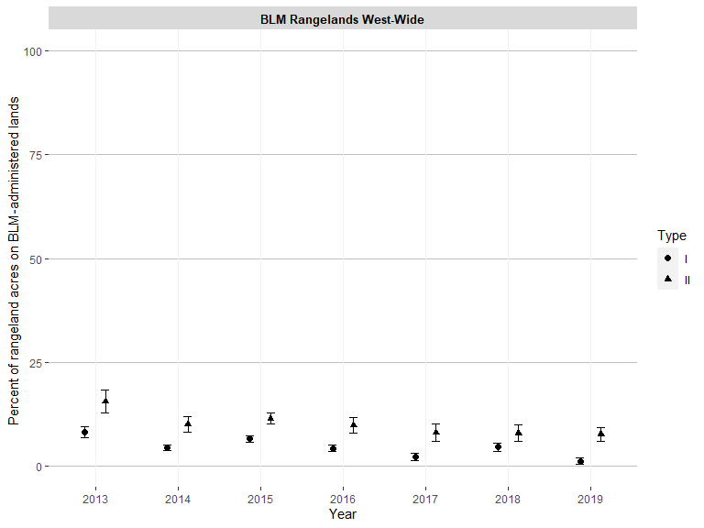

Figure 22: BLM rangeland acres with moderate or moderate-to-extreme or extreme-to-total departure from soil and site stability reference conditions (SSS >= 3) (80% confidence interval)
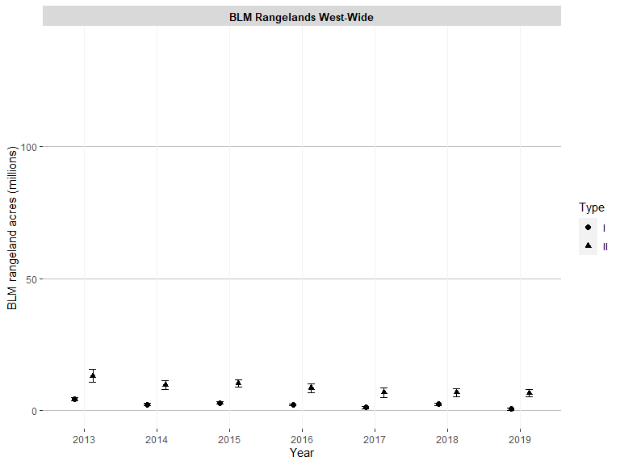

Figure 23: Proportion of BLM rangelands with moderate-to-extreme or extreme-to-total departure from soil and site stability reference conditions (SSS >= 4) (80% confidence interval)
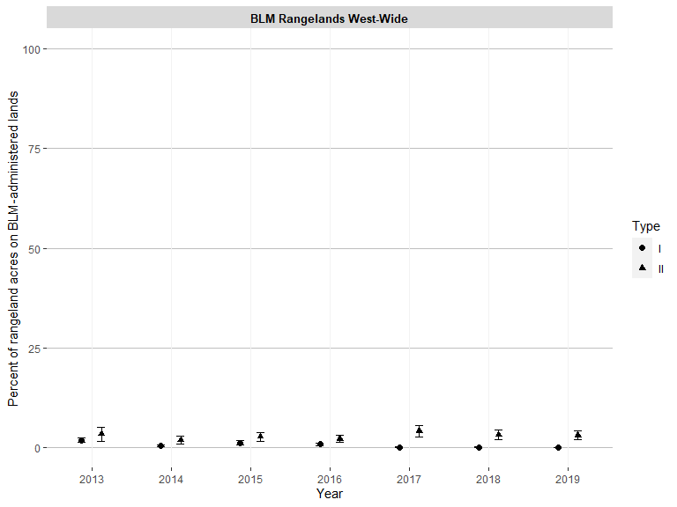

Figure 24: BLM rangeland acres with moderate-to-extreme or extreme-to-total departure from soil and site stability reference conditions (SSS >= 4) (80% confidence interval)
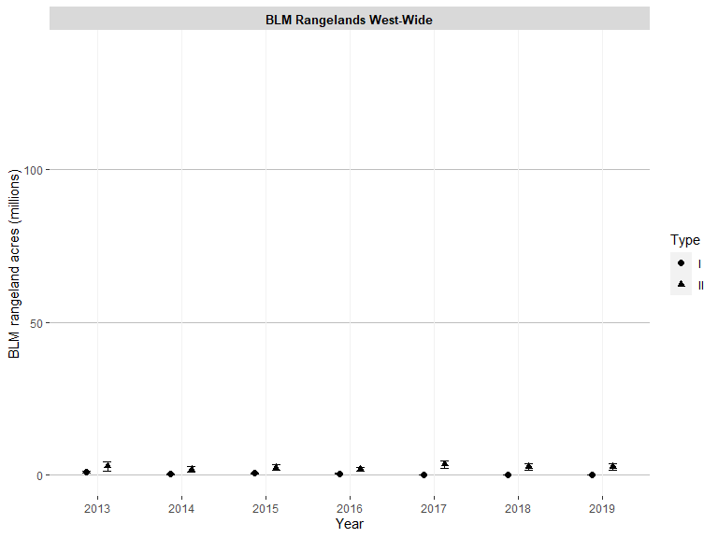

Figure 25: Proportion of BLM rangelands where all 3 rangeland health attributes had none-to-slight or slight-to-moderate departure from reference conditions (<= 2) (80% confidence interval)
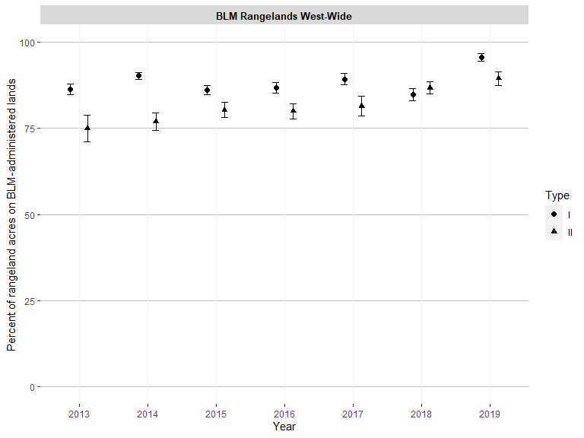

Figure 26: BLM rangeland acres where all 3 rangeland health attributes had none-to-slight or slight-to-moderate departure from reference conditions (<= 2) (80% confidence interval)
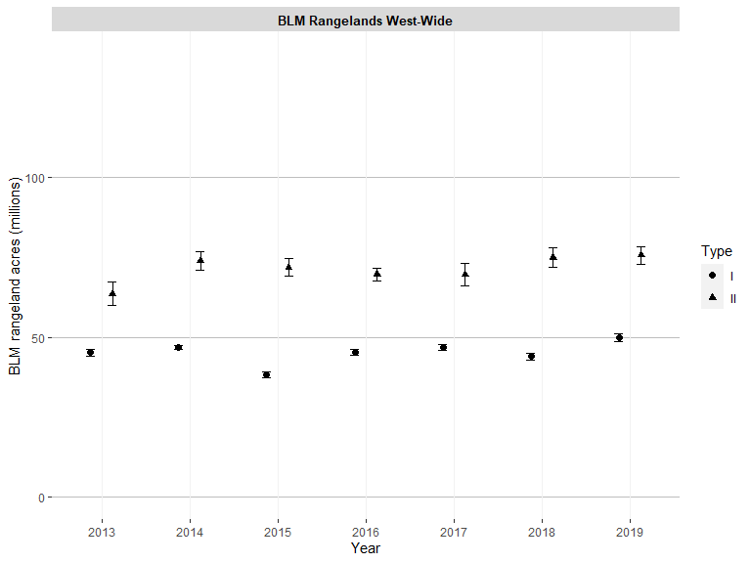

Figure 27: Proportion of BLM rangelands where all 3 rangeland health attributes had moderate-to-extreme or extreme-to-total departure from reference conditions (>= 4) (80% confidence interval)
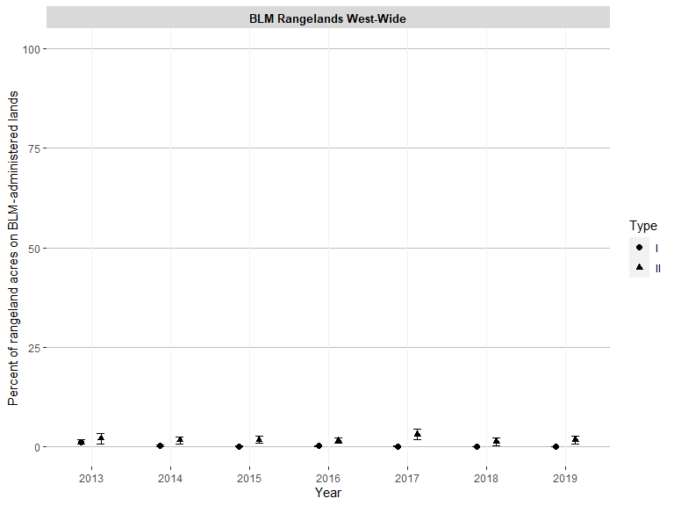

Figure 28: BLM rangeland acres where all 3 rangeland health attributes had moderate-to-extreme or extreme-to-total departure from reference conditions (>= 4) (80% confidence interval)
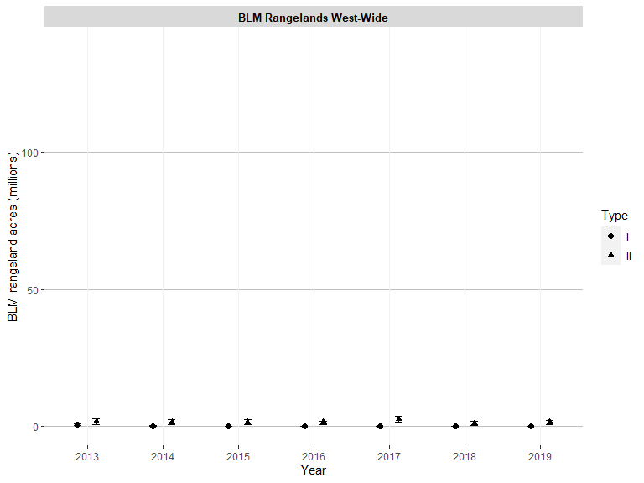

Figure 29: Proportion of BLM rangelands where at least 1 rangeland health attribute had moderate departure from reference conditions (= 3) (80% confidence interval)
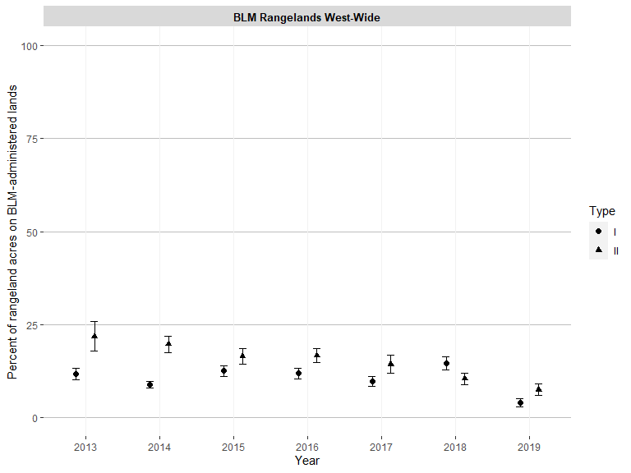

Figure 30: BLM rangeland acres where at least 1 rangeland health attribute had moderate departure from reference conditions (= 3) (80% confidence interval)
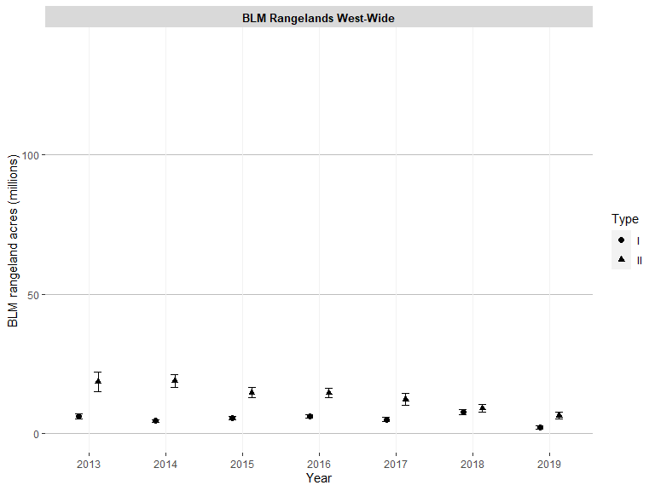

Figure 31: Proportion of BLM rangelands with non-native invasive species present (80% confidence interval)
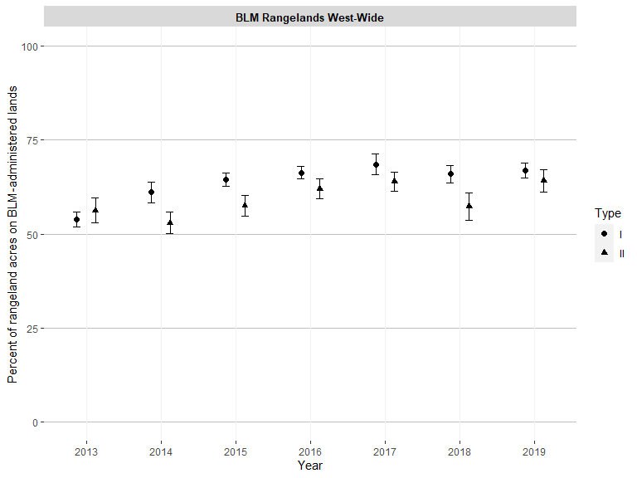

Figure 32: BLM rangeland acres with non-native invasive species present (80% confidence interval)
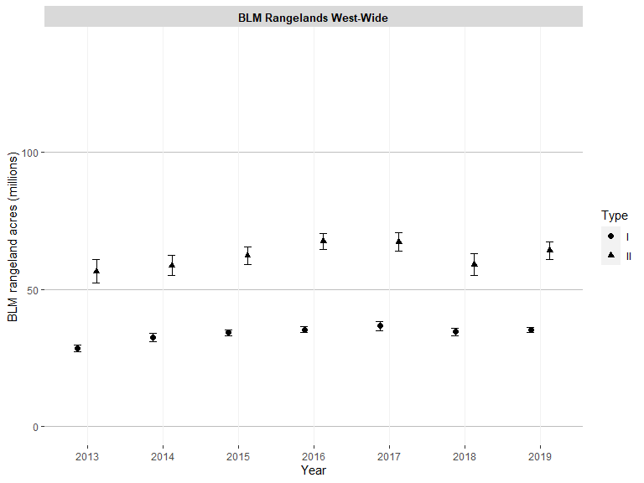

Figure 33: Proportion of BLM rangelands where non-native invasive species are abundant (>= 25%) (80% confidence interval)
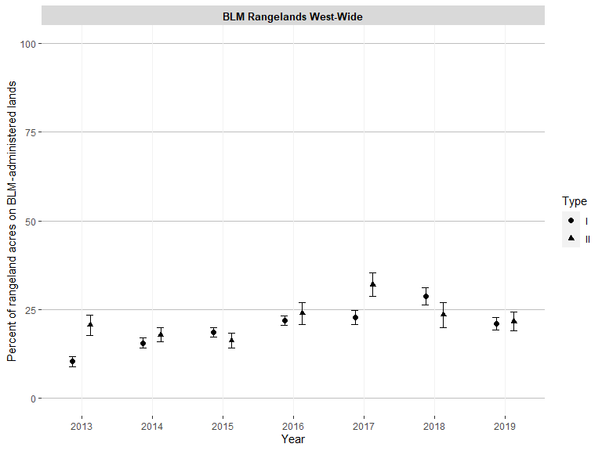

Figure 34: BLM rangeland acres where non-native invasive species are abundant (>= 25%) (80% confidence interval)
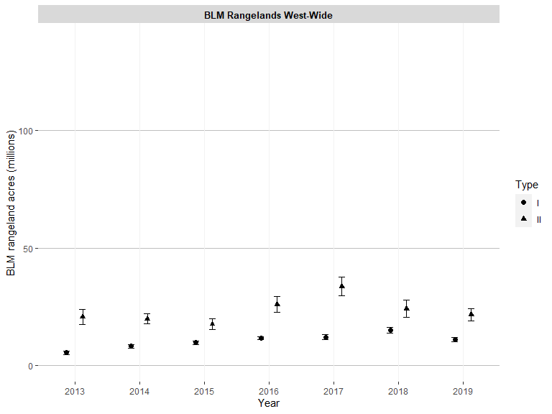

Figure 35: Proportion of BLM rangelands with at least 20% of land having intercanopy gaps of at least 2 meters (80% confidence interval)
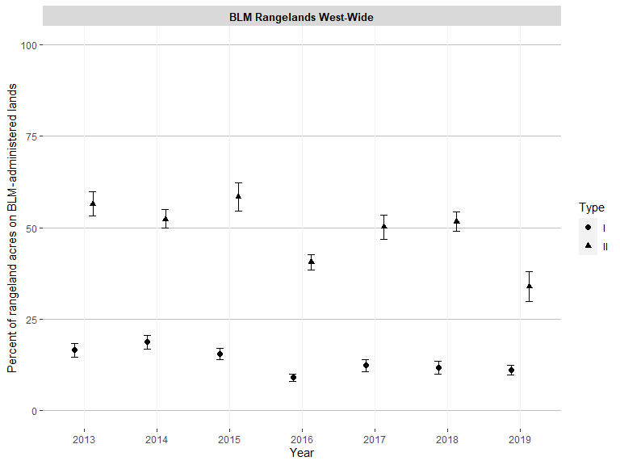

Figure 36: BLM rangeland acres with at least 20% of land having intercanopy gaps of at least 2 meters in length (80% confidence interval)
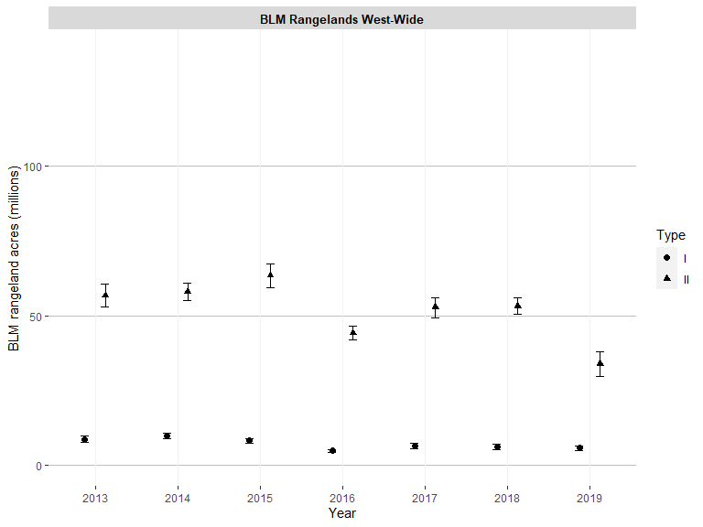

Figure 37: Proportion of BLM rangelands with at least 20% of land having intercanopy gaps of at least 2 meters and gaps are at least 50% bare ground (80% confidence interval)
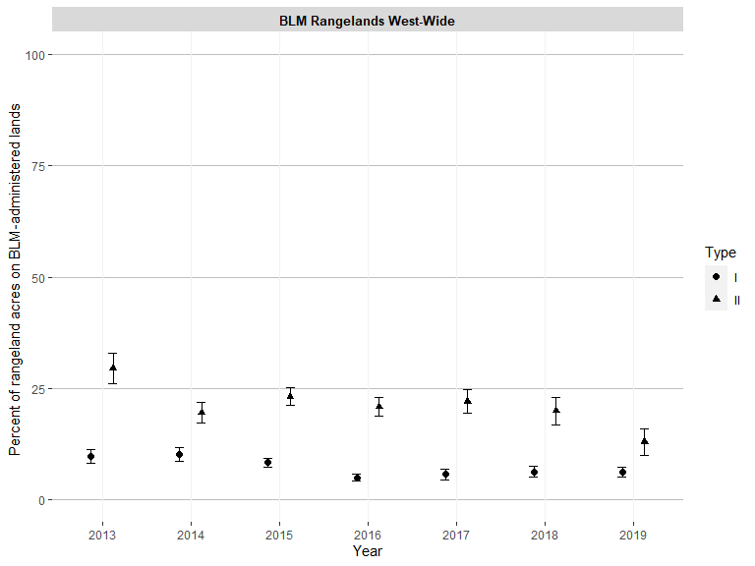

Figure 38: BLM rangeland acres with at least 20% of land having intercanopy gaps of at least 2 meters and gaps are at least 50% bare ground (80% confidence interval)
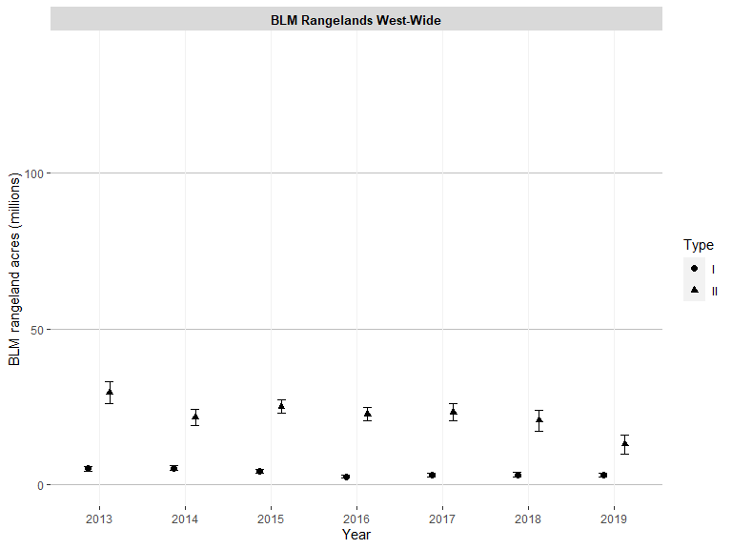

Figure 39: Percent cover of bare ground on BLM rangelands (80% confidence interval)
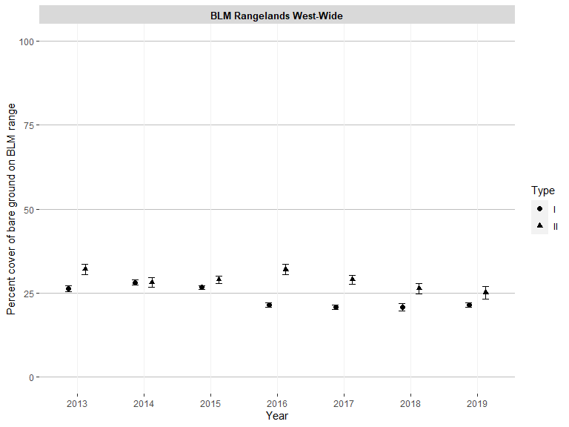

Figure 40: Proportion of BLM rangelands with at least 20% bare ground (80% confidence interval)
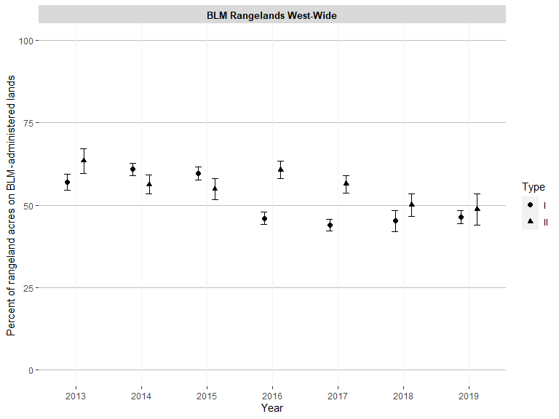

Figure 41: BLM rangeland acres with at least 20% bare ground (80% confidence interval)
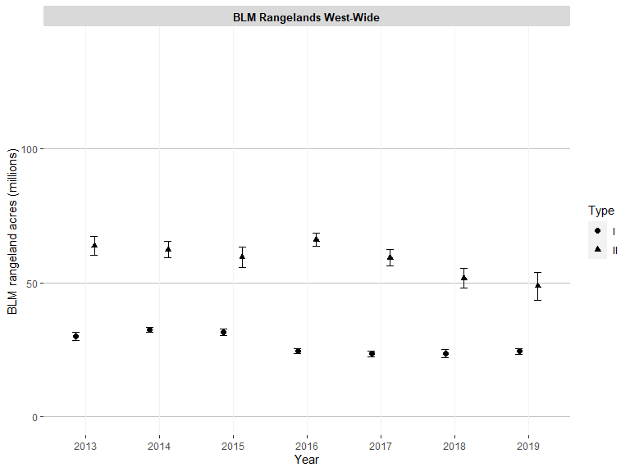

Figure 42: Proportion of BLM rangelands with at least 30% bare ground (80% confidence interval)
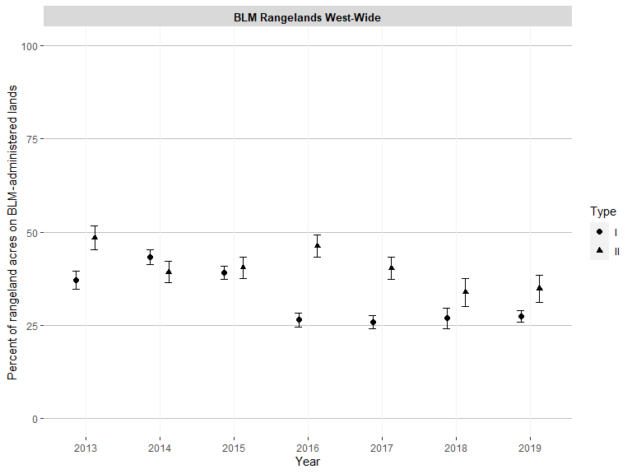

Figure 43: BLM rangeland acres with at least 30% bare ground (80% confidence interval)
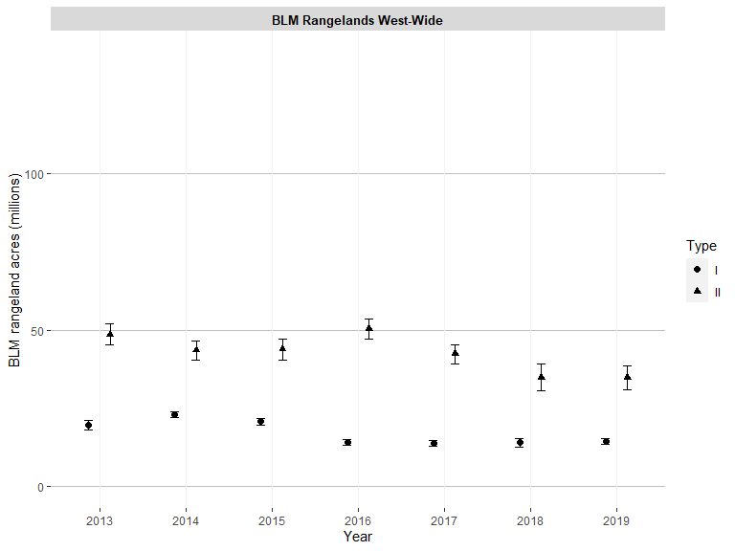

Figure 44: Proportion of BLM rangelands with at least 40% bare ground (80% confidence interval)
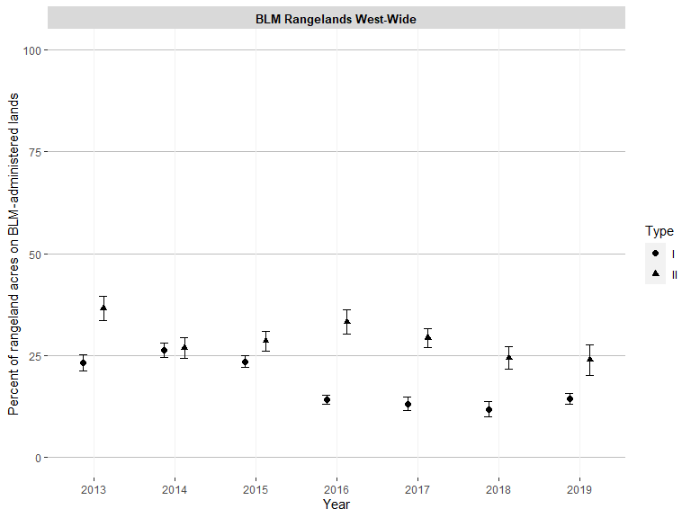

Figure 45: BLM rangeland acres with at least 40% bare ground (80% confidence interval)
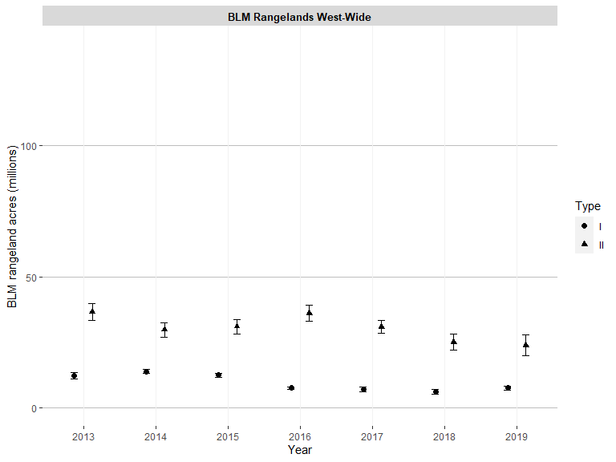

Figure 46: Proportion of BLM rangelands with at least 50% bare ground (80% confidence interval)
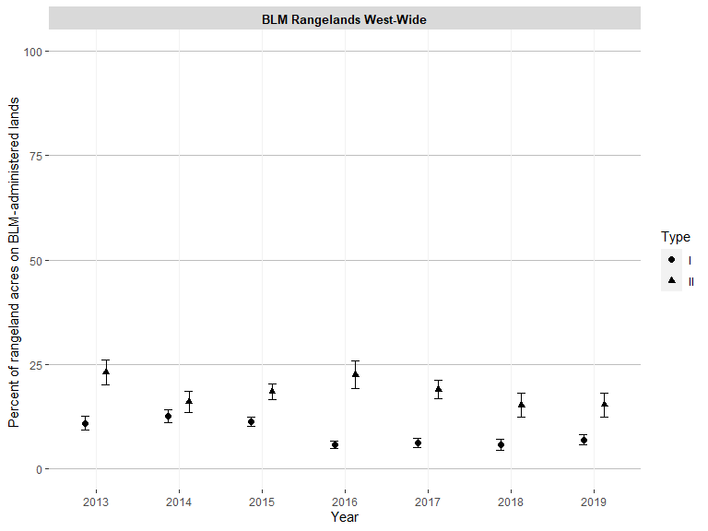

Figure 47: BLM rangeland acres with at least 50% bare ground (80% confidence interval)
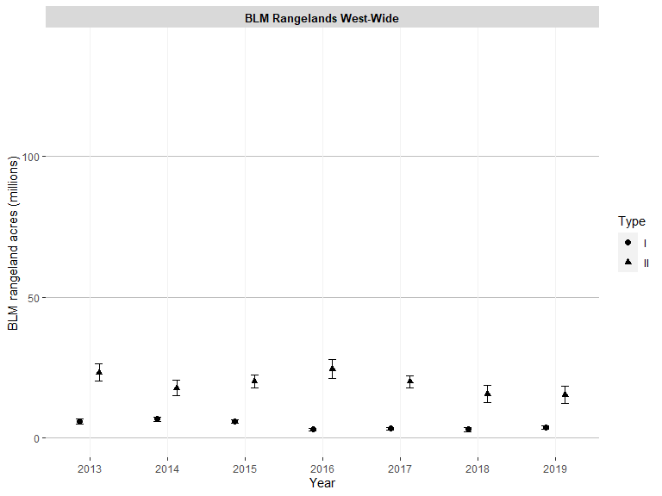

Figure 48: Proportion of BLM rangelands where soil aggregate stability is ranked 4 or less (80% confidence interval)
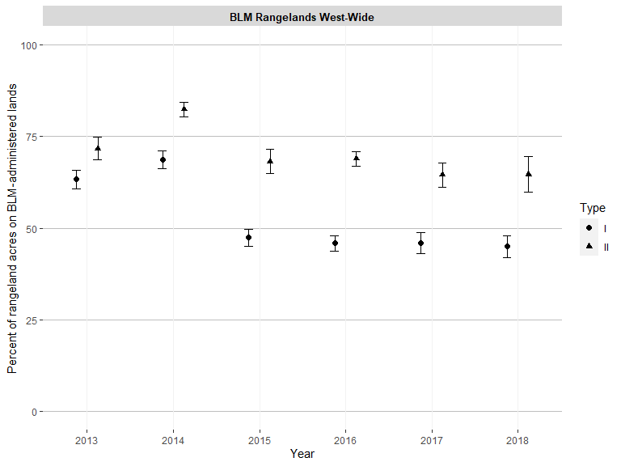

Figure 49: BLM rangeland acres where soil aggregate stability is ranked 4 or less (80% confidence interval)
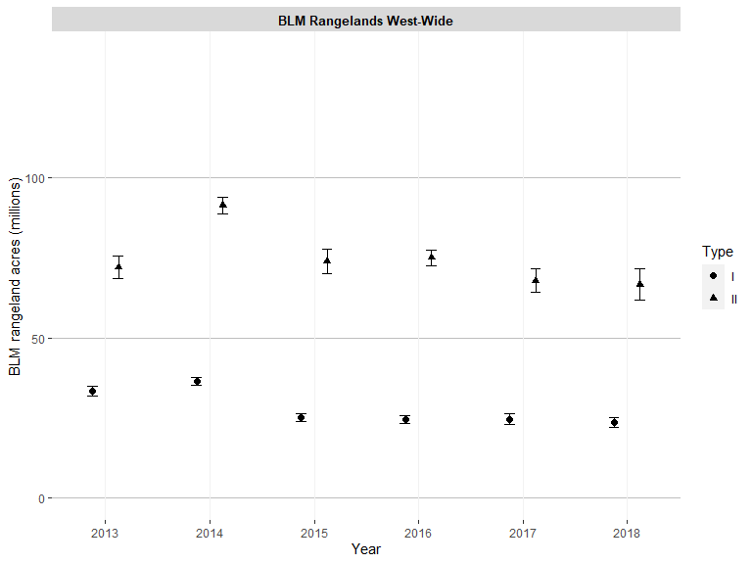

Figure 50: Percent cover of sagebrush on BLM rangelands (80% confidence interval)
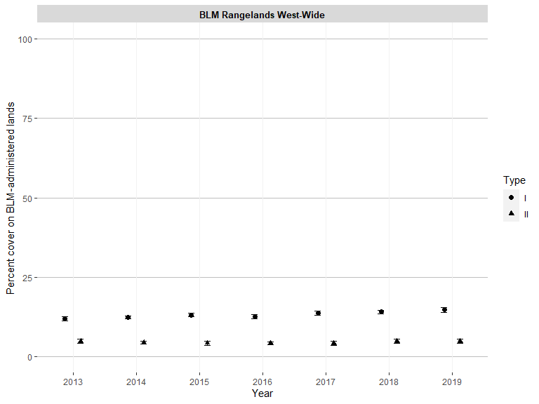

Figure 51: Mean sagebrush species height in inches on BLM rangelands (80% confidence interval)
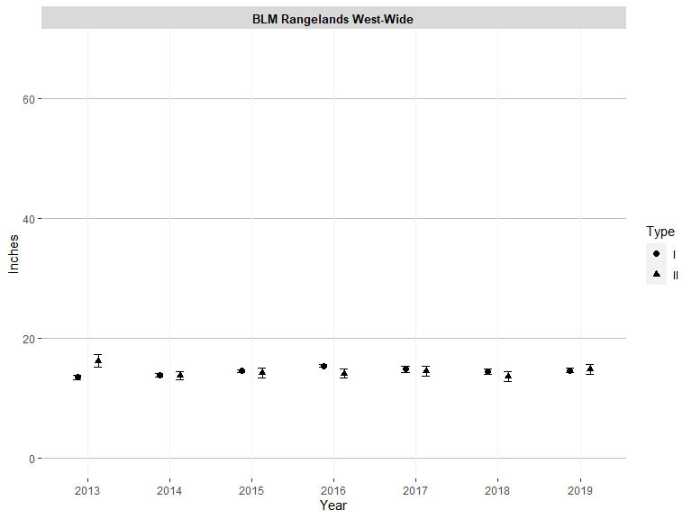

Figure 52: Proportion of sagebrush that is columnar shaped on BLM rangelands (80% confidence interval)
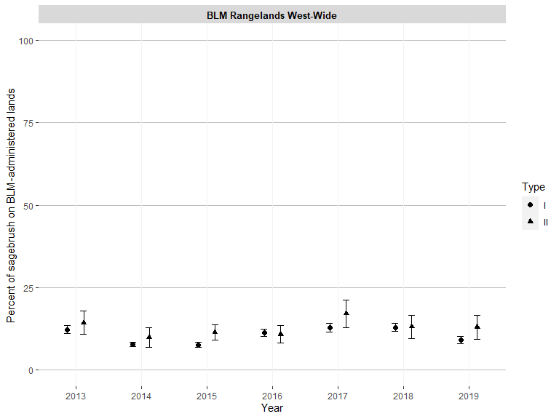

Figure 53: Proportion of sagebrush that is spreading shaped on BLM rangelands (80% confidence interval)
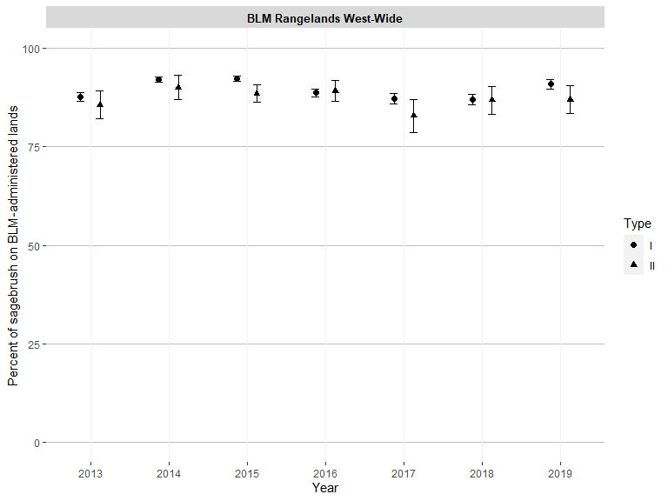

Figure 54: Mean herbaceous plant species height in inches on BLM rangelands (80% confidence interval)
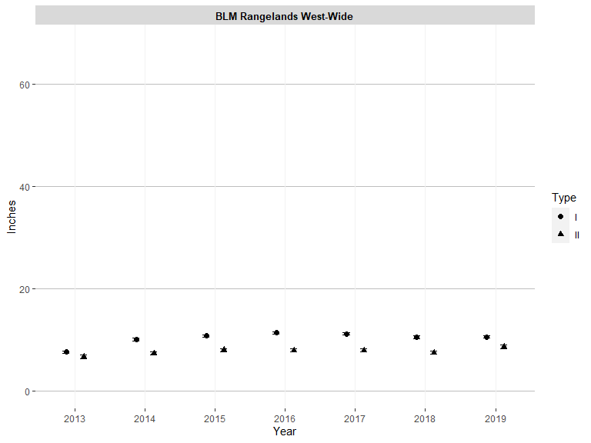

Figure 55: Percent cover of perennial grasses and perennial forbs on BLM rangelands (80% confidence interval)
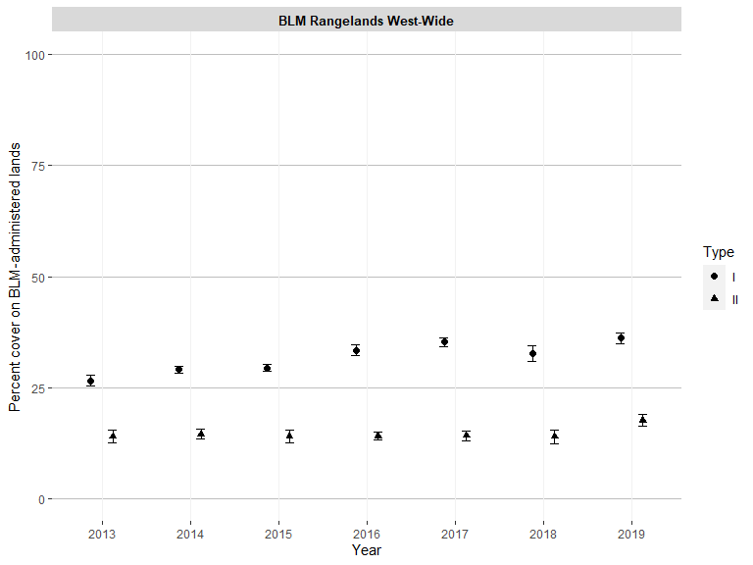

Figure 56: Percent cover of bare ground on BLM rangelands (80% confidence interval)
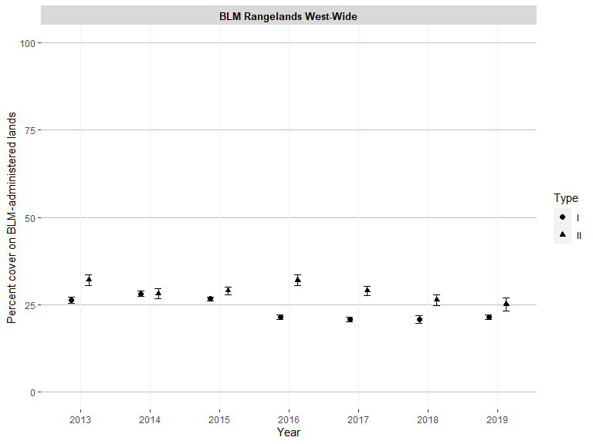

Figure 57: Proportion of vegetation composed of annual grasses on BLM rangelands (80% confidence interval)
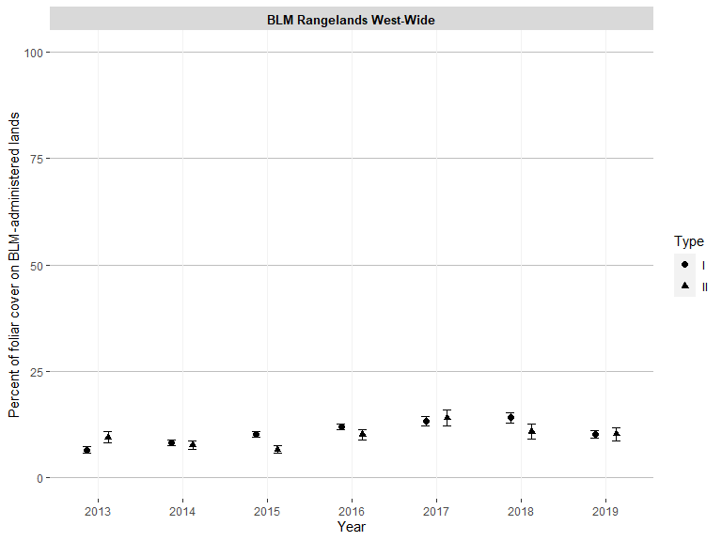

Figure 58: Proportion of vegetation composed of non-native invasive plant species on BLM rangelands (80% confidence interval)
